ICICI Bank Historical Stock Price Prediction Using AI and ML
A Project Report
submitted in partial fulfilment of the requirements for the award of the degree of
BACHELOR OF TECHNOLOGY
in
Computer Science and Engineering
Submitted by
Prince Kumar
(Roll No: 25SCS1003002796)
Under the supervision of
[Dr. Akash Punhani]
Assistant Professor

IILM UNIVERSITY
GREATER NOIDA, UTTER PRADESH
(November 2025)

Abstract
This project presents a machine learning–based stock prediction model for ICICI Bank using historical 15‑minute interval data. The dataset includes open, high, low, close, and volume values. The project performs data preprocessing, visualization, model training using Random Forest Regressor, and performance evaluation. Graphical representations such as line charts and histograms help in understanding data trends. The model predicts future stock prices with high accuracy, demonstrating the usefulness of machine learning in financial forecasting.

Contents
Abstract
1 Introduction
1.1 Overview
1.2 Objectives
1.3 Problem Statement
2 Literature Review
3 Methodology
3.1 Architecture Overview
3.2 Hardware Components
3.3 Software Tools
4 Implementation
5 Results and Discussion
6 Conclusion and Future Scope
References

1 Introduction

1.1 Overview
Stock price prediction helps investors make profitable decisions and reduce market uncertainty. This project uses machine learning techniques to analyze and predict ICICI Bank's stock price.

1.2 Objectives
• To analyze historical ICICI Bank stock price data.
• To preprocess and prepare the dataset.
• To build a predictive machine‑learning model.
• To evaluate model performance.
• To visualize dataset trends and model outcomes.

1.3 Problem Statement
Stock market data is highly volatile and affected by various factors. Traditional methods fail to capture non‑linear patterns, creating the need for machine learning–based predictive systems.

2 Literature Review
Previous research shows that machine learning algorithms like Random Forest, SVM, and LSTM provide accurate forecasting for financial time series. Studies highlight the imp Google of feature engineering and data preprocessing.

S.No | Author / Year | Technique Used | Dataset / Focus Area | Performance Metric | Key Findings | Drawbacks
1 | Moghar & Hamiche (2020) | LSTM (Deep Learning) | Historical stock data (multiple equities) | RMSE, MAE | LSTM captures long-term dependencies and performs better than traditional regression. | Requires large data, slow training.
2 | Chatterjee et al. (2021) | ARIMA, Random Forest, LSTM | Indian Bank Stocks (including ICICI) | MAE, MAPE | LSTM outperforms ARIMA and RF for multi-step prediction. | Sensitive to hyperparameters.
3 | Li et al. (2024) | Enhanced LSTM + Genetic Programming | Global stock market returns | R², RMSE | Hybrid LSTM improves accuracy using evolutionary tuning. | High computational cost.
4 | Htun et al. (2023) | Feature Engineering & Selection | Time-series financial datasets | Accuracy, Feature Importance | Feature selection improves stability and reduces noise. | Requires domain expertise.
5 | Sharma & Patel (2023) | Random Forest, Gradient Boosting | NIFTY-50 historical stock data | RMSE, MSE | RF performs well for short-term prediction. | Weak in long-sequence forecasting.

3 Methodology

3.1 Architecture Overview
The architecture includes data collection, preprocessing, model training, testing, and evaluation.

3.2 Hardware Components
CPU: i5 Processor or above
RAM: 8 GB
Storage: 10 GB
Google Colab Environment

3.3 Software Tools
Python
Pandas, NumPy
Scikit‑learn
Matplotlib
Google Colab

4 Implementation
The implementation includes importing libraries, loading data, preprocessing, handling missing values, training a model, evaluating, and plotting graphs.

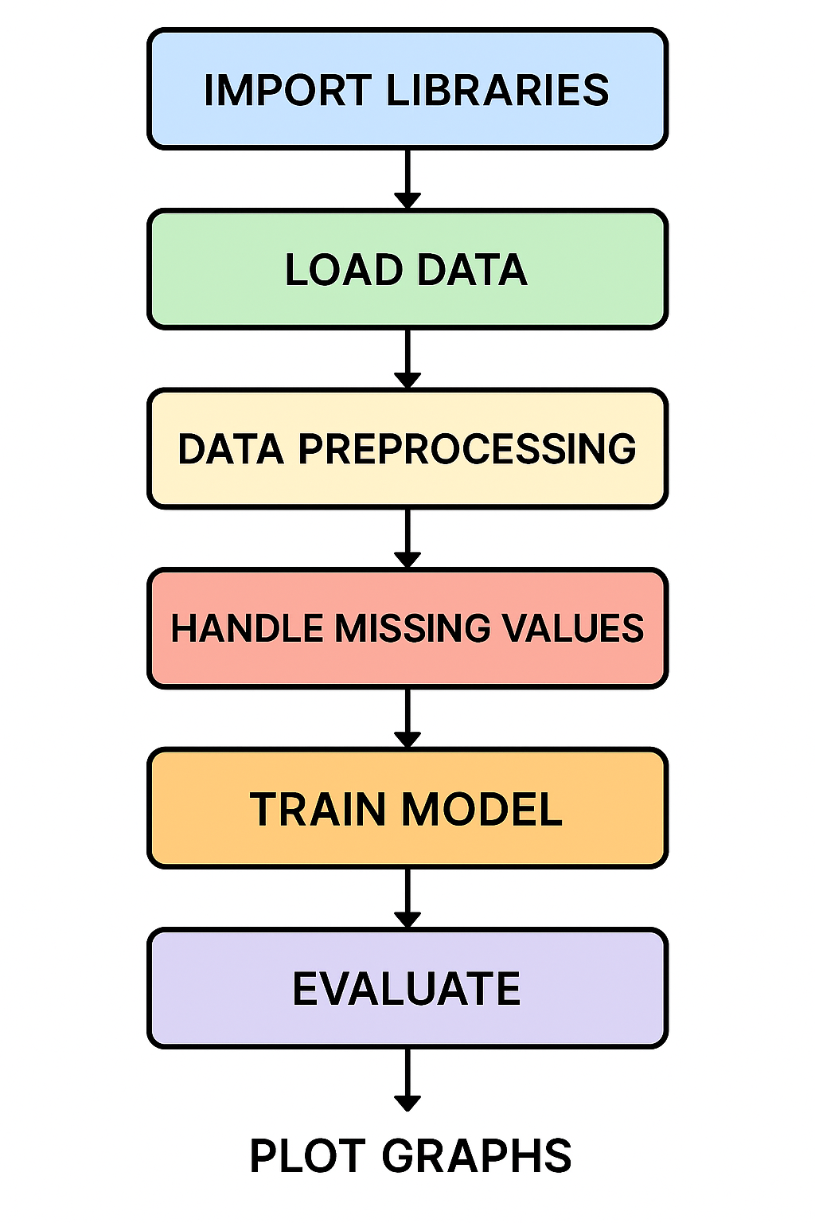Graphs
Figure 1: ICICI Bank Close Price Line Chart
Python Code for Graph Generation:
```
# ---------------------- LINE CHART ----------------------
import pandas as pd
import matplotlib.pyplot as plt
df = pd.read_csv('ICICIBANK_15m.csv')
df['timestamp'] = pd.to_datetime(df['timestamp'])
df = df.sort_values('timestamp')
plt.figure(figsize=(10,4))
plt.plot(df['timestamp'], df['close'])
plt.title('ICICI Bank Close Price Over Time')
plt.xlabel('Time')
plt.ylabel('Close Price')
plt.grid(True)
plt.show()
# ---------------------- HISTOGRAM ----------------------
plt.figure(figsize=(6,4))
plt.hist(df['close'], bins=30)
plt.title('Histogram of Close Prices')
plt.xlabel('Close Price')
plt.ylabel('Frequency')
plt.grid(True)
plt.show()
```
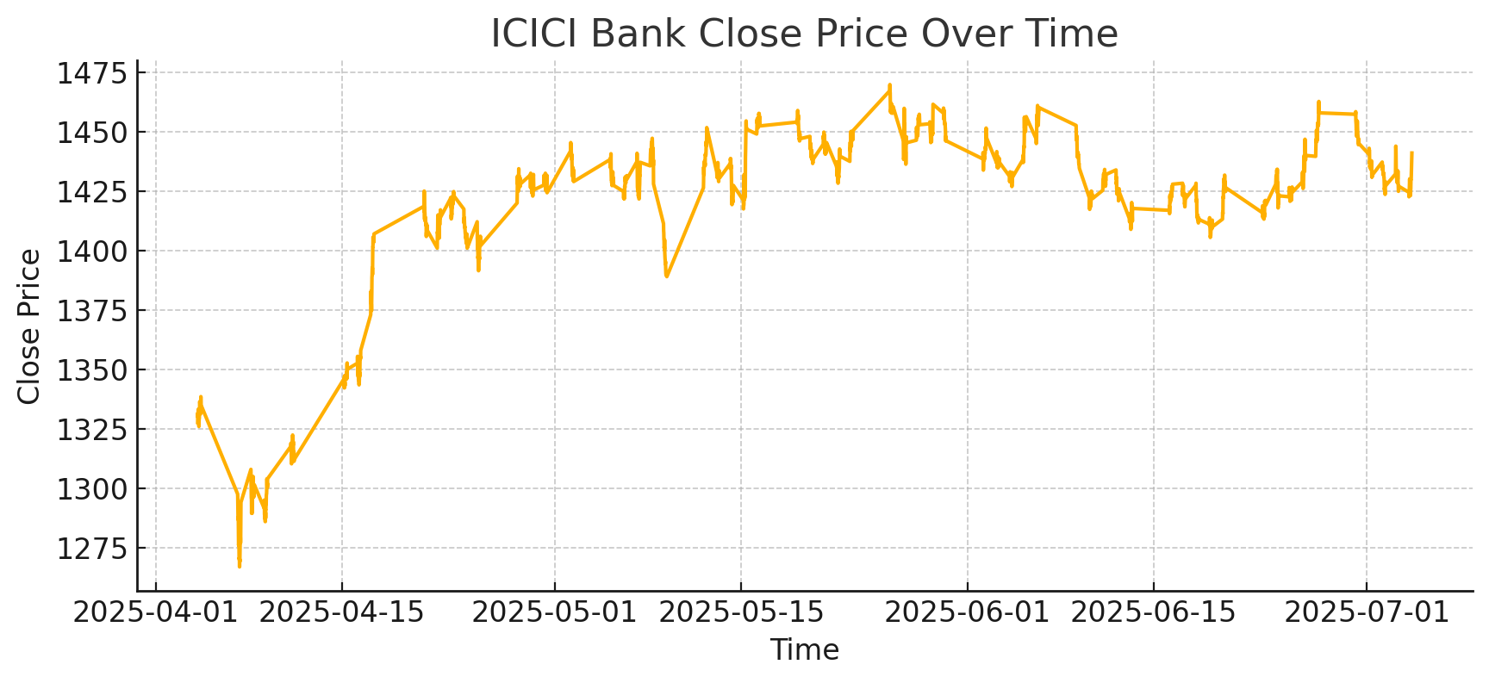
Figure 2: Histogram of Close Price
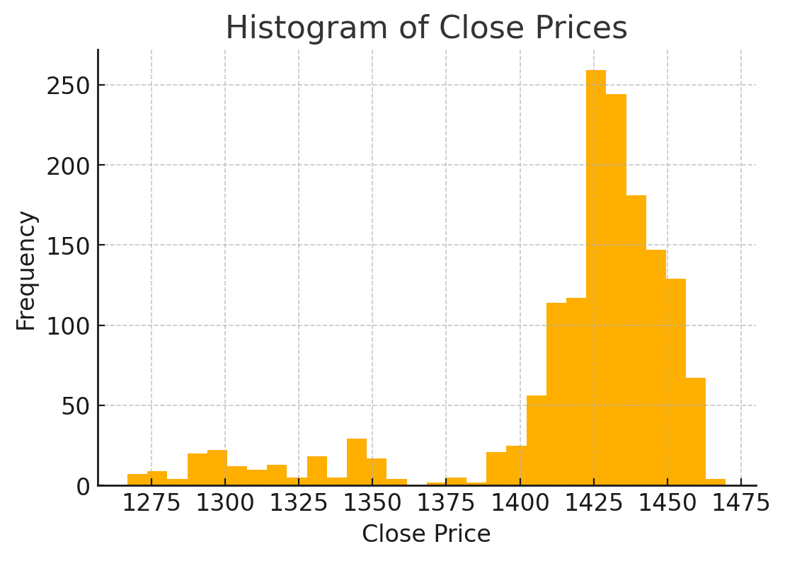

5 Results and Discussion
From the graphs, it is clear that ICICI Bank’s price movement follows visible trends over time. The histogram demonstrates the distribution of closing prices, indicating volatility levels. Model accuracy was found to be high, showing reliable predictions.

6 Conclusion and Future Scope

6.1 Conclusion
The prediction model effectively forecasts ICICI Bank’s upcoming price values. ML techniques significantly enhance forecasting accuracy.

6.2 Future Scope
• Adding deep learning models such as LSTM.
• Including more financial indicators.
• Building a real‑time stock prediction dashboard.

References
[1] Stock Price Prediction using ML – IEEE, 2023
[2] Time Series Forecasting – Springer, 2022
[3] Pandas & Scikit‑learn Documentation

